In this assignment you will implement methods in the Database tier of a program that manages Players data. Specifically,

Download the starter code: player.zip

Download player.zip which contains the Business tier (player_objects.py) , Presentation tier (player_ui.py) and partially implemented Database tier (player_db.py). It also contains the SQLite database for Player's data: player_db.sqlite.

As you can see from the player_objects.py file and the database, each Player has name, wins, losses, ties and id as attributes. It also has a property games which is the total of wins, losses and ties.

You will implement the methods of the Database tier that provide access to the player_db.sqlite database: get_players, get_player, add_player, delete_player as described in the player_db.py file.

These Database tier methods are called by the commands in the Presentation tier so that the UI works as follows:

viewall command: prints the players' data in order by wins, starting with the player with the most wins.

view command: prompts for the name of the player whose data is to be viewed, and prints the data.

add command: prompts for the name, wins, losses and ties data for the new player. That data for the new player is added to the database.

delete command: prompts for the name of the player to be deleted, and deletes that player's data from the database.

Notes:

Assume that the name for each player is unique.

Don't make any changes to the Presentation or business tier files. Only submit the player_db.py file.

Database tier changes:

Before you start, be sure to save a copy of the player_db.sqlite file as you may end up corrupting or losing data in it as you are writing and testing your changes. You can then always recover the file from your backup copy if needed.

Be sure that the methods that update the database call commit() so the updates are saved to the player_db.sqlite.

Here's a sample run:

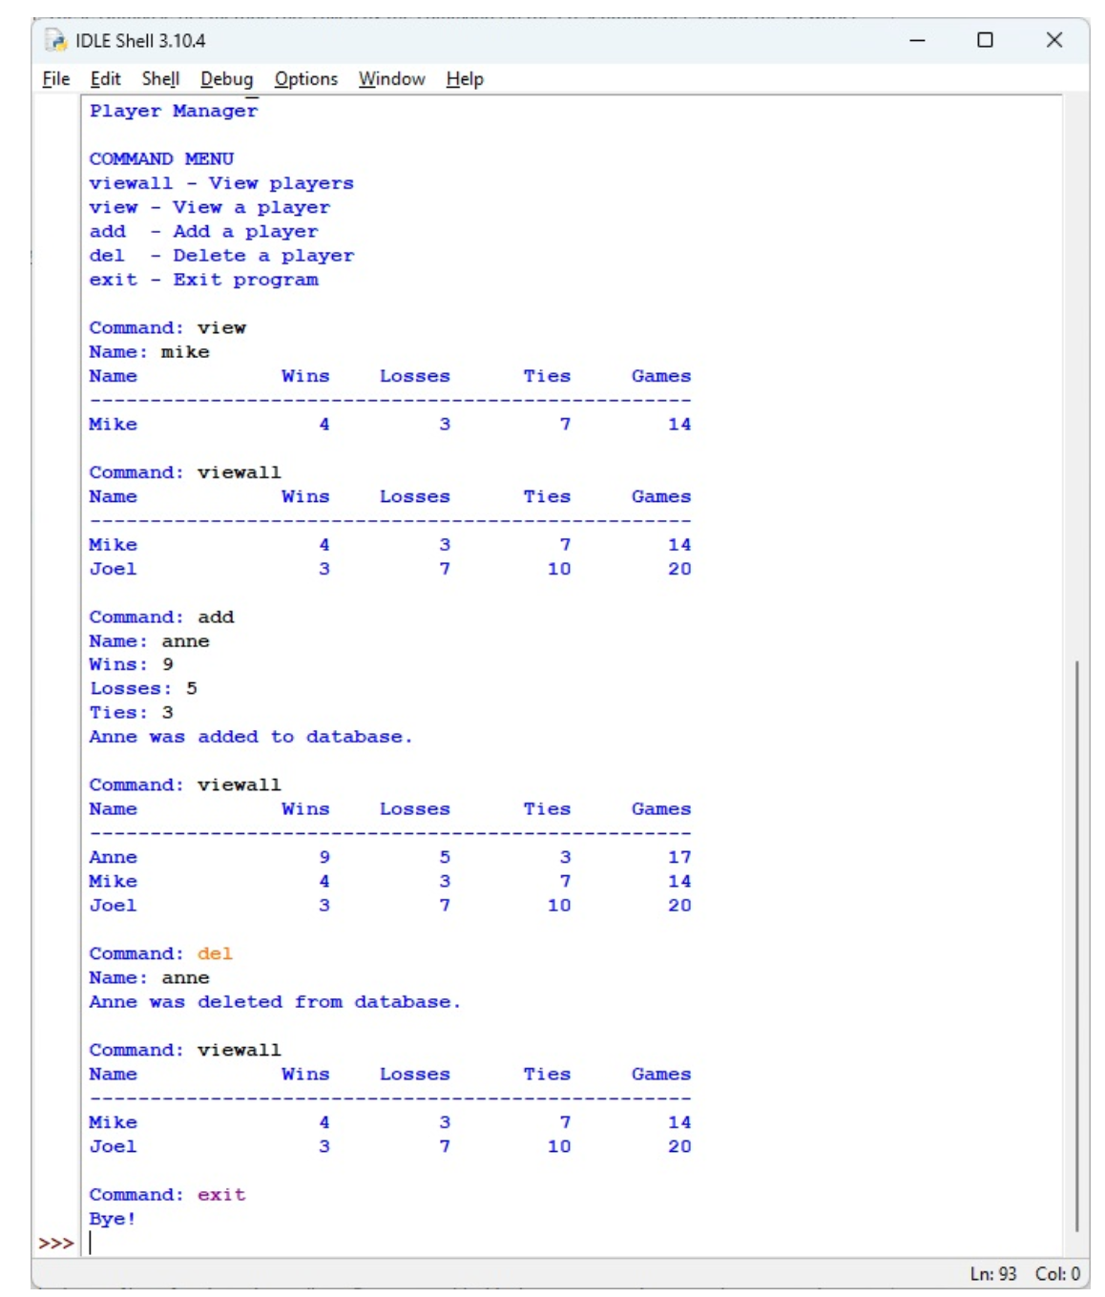

Submit your file as first_last_player_db.py. Be sure to add a block-comment at the top and comments in your code.